BF[2] project: You can choose from the list of projects below (or convince me of a project you feel would be better), but you are required to do the following:

1. Choose only two factors
2. Have at least two levels each one factor.
3. Replicate at least 5 times for each treatment combination
4. Determine the best way to do randomization of your experiment, and describe your randomization process.
5. For the report, please include the following:
   1. Introduction
      1. What is your research question?

Do I make more basketballs from 10 or 15 feet away depending on the basket type.

* + 1. What are the null and alternative hypotheses?

Ho: All basket types are equal.

Ha: at least one is different.

* 1. Data Collection
     1. How did you randomize?

I put the basket types in a hat and randomly drew a piece of paper out of hat at each location that was previously selected.

* + 1. What was the factor(s) and response?

The factors were basket type and location, and the response was how many shots made from 10.

* 1. Factor Structure
     1. Write the algebraic model for the experiment. Including subscripts and definitions of terms and subscripts in the model.
     2. Describe what design you planned on using

A 2-way ANOVA test.

* 1. Descriptive Statistics
     1. Numerical Descriptive Statistics

|  |
| --- |
| location_feet.basket_type min Q1 median Q3 max mean sd n missing  1 10.blocks holder 6 7 8 8 10 7.8 1.483240 5 0  2 15.blocks holder 2 2 4 5 6 3.8 1.788854 5 0  3 10.garbage can 5 5 7 9 9 7.0 2.000000 5 0  4 15.garbage can 2 5 8 8 8 6.2 2.683282 5 0  5 10.laundry basket 2 6 6 8 8 6.0 2.449490 5 0  6 15.laundry basket 1 2 4 7 8 4.4 3.049590 5 0 |
|  |
| |  | | --- | | > | |

* + 1. Graphical Descriptive Statistics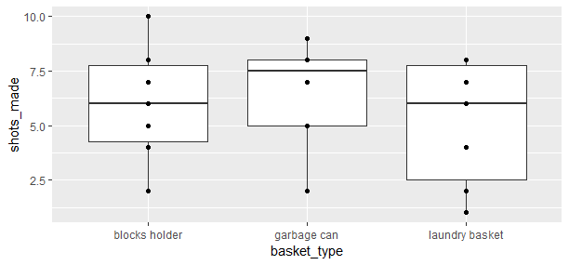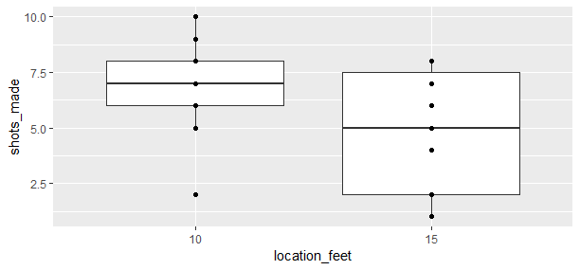
    2. “Tell a story” based on what you see in your descriptive statistics

With this boxplot we can tell the means don’t change very much based on the basket type. The location doesn’t tell us much either.

* 1. Inferential Statistics
     1. Checking Requirements. State if requirements are met or not and how you decided. If requirements aren’t met, try to fix things with a transformation or other solution.
     2. ANOVA table, df,SS, MS, F, p-value.

1. Analysis of Variance Table
2. Response: shots_made
3. Df Sum Sq Mean Sq F value Pr(>F)
4. basket_type 2 9.867 4.933 0.9279 0.40911
5. location_feet 1 34.133 34.133 6.4201 0.01823 *
6. basket_type:location_feet 2 13.867 6.933 1.3041 0.28997
7. Residuals 24 127.600 5.317
8. ---
9. Signif. codes: 0 ‘***’ 0.001 ‘**’ 0.01 ‘*’ 0.05 ‘.’ 0.1 ‘ ’ 1
   * 1. Decision rule (level of significance). Call out the specific p-value so that I know you are reading the correct piece of output.

I am looking for interaction between the factors so the p-value of 0.28997 tells us we have insufficient evidence to reject the null.

* + 1. Any mean differences or mean treatment combinations that stand out? If ANOVA F is significant, perform tests to determine which means or interesting contrasts are significant. Summarize your findings.

It surprises me that there isn’t significance that something is different in the interaction.

* + - 1. Choose the appropriate multiple comparison adjustment technique you applied and explain your choice (or if you chose not to adjust, justify that as well).
  1. Conclusion
     1. General Conclusion of your results based on decision rule

That the location and the type of basket has no effect on how many shots I make out of 10 shots. But if I went away from the interaction the location shows significance that it effects how many I made.

* + 1. Why do you think you got the results you did?

I think I got the results I did because I was the one who was shooting. If I would have done it between me and my wife and even a few other people I think the results would have been much different.

* + 1. What would you have done differently?

I would have added more people.

* + 1. Any follow up studies that you would have done?

Different possible projects:

1. factors:

clothes dryer (A,B), temperature setting, load

responses:

time until dryer stops

1. factors:

pan (aluminum, iron), burner on stove, cover for pan (no, yes)

responses:

time to boil water

1. factors:

pack on back (no, yes), footwear (tennis shoes, boots), run (7, 14 flights of steps)

responses:

time required to run up steps and heartbeat at top

1. factors:

width to height ratio of paper sheet, slant angle, dihedral angle, weight added, thickness of paper

responses:

length of flight of paper airplane

1. factors:

brand of rubber band, size, temperature

responses:

length of rubber band before it broke

1. factors:

orientation of football, kick (ordinary, soccer style),steps taken before kick, shoe (soft, hard)

responses:

distance football was kicked

1. factors:

distance from basket type of shot, location on floor

responses:

number of shots made (out of 10) with basketball

1. factors:

temperature, position of glass when pouring soft drink, amount of sugar added

responses:

amount of foam produced when pouring soft drink into glass